EC2 State Change Notifications

## Step by Step Implementation

### Create ‘EC2StateChangeRule’

We need to create this rule as shown in the image below.

* Console: Amazon EventBridge → Rules → Create rule.
* Rule name: EC2StateChangeRule. Add a short description if you want.
* Event bus: default.
* Rule type: Rule with an event pattern.

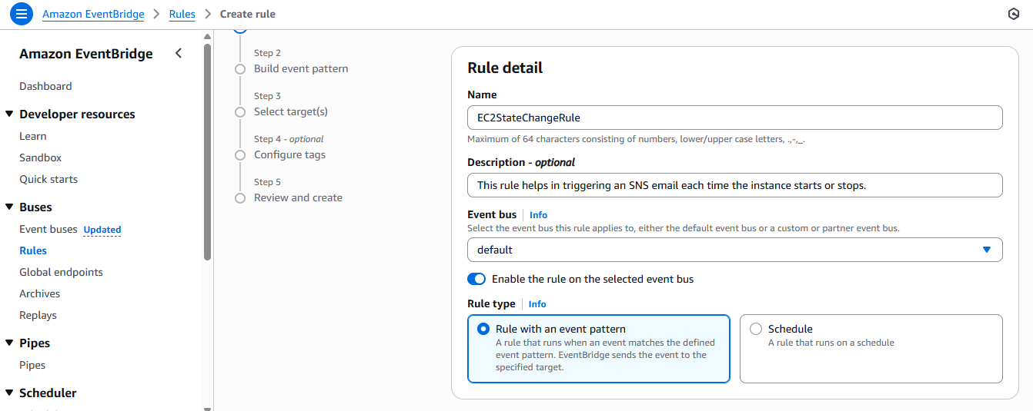

* For Event source choose AWS services.
* AWS service: EC2.
* Event type: EC2 Instance State-change Notification.
* Under Specific states, tick - running stopped.
* Under Event Type Specification, choose Specific instance Id(s) and enter your instance ID(s) (so only that instance triggers the rule).

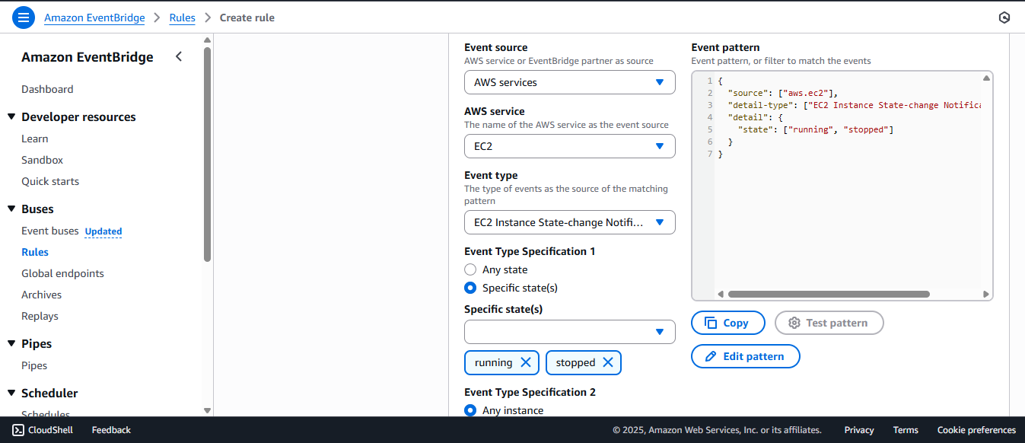

Make sure this eventbridge rule is enabled. Refer to the image below.

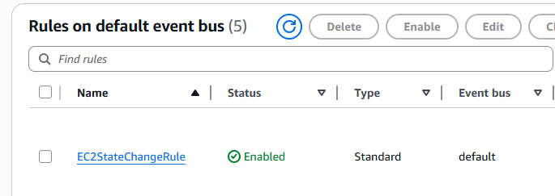

### Create an SNS topic and subscription.

Here, as we can see, we need to choose the type either FIFO or standard.For   
this task, I have chosen the standard type.

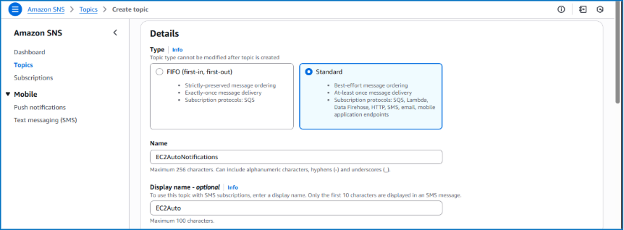

We need to choose a protocol (Email for this task) and endpoint – the desired email ID. 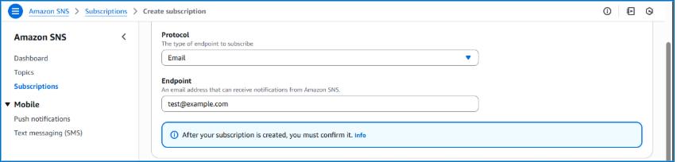

### Results

Manually Stop or Start the EC2 instance from the EC2 console

You should receive an email from the SNS topic (confirm your subscription beforehand).

I started my instance to test these notifications. As you can see the state is “running”.   
Similarly, state “stopped”-

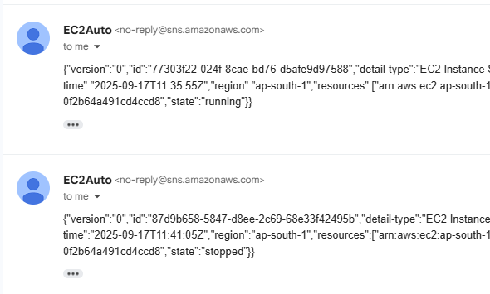

## Conclusion

With the EC2StateChangeRule in place, every start or stop event of the instance is captured in real time by EventBridge and delivered to SNS, ensuring I receive immediate email notifications even if the action wasn’t triggered by Lambda.